Project 1

Instructions

For this assignment/project, you are required to create a one-page website (or optionally one representative page of a website) about any topic in any style. The layout of the web page MUST follow both of the wireframes provided below. Visual elements such as graphics must be used, and properly geared towards the goal of design – neat, engaging, and easy to follow.

Wireframe.1 Wireframe.2

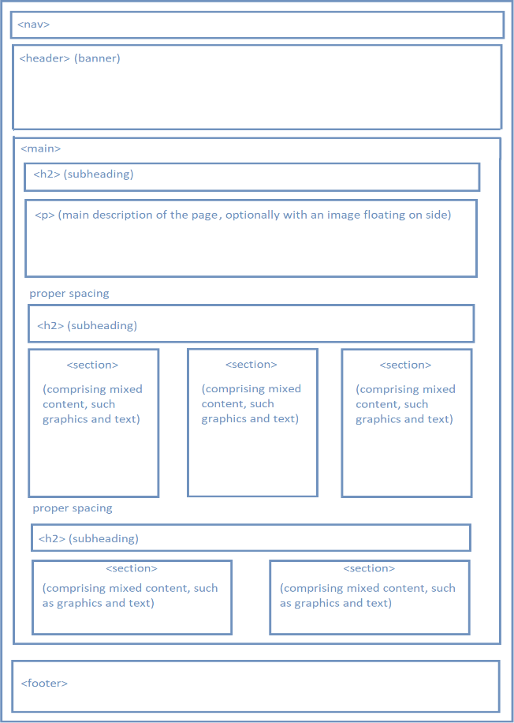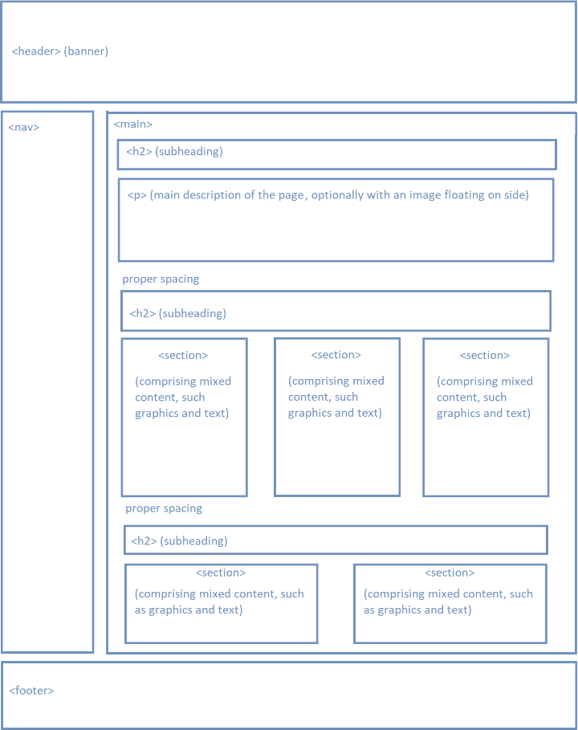

Note:

* Graphics from internet must be cited exactly.
* All (sub)headings, navigation link texts must be meaningful (not Lorem text).
* See Rubrics for grading criteria. MUST be coded from scratch, no templates or external libraries (except fonts) allowed. All external libraries will be removed when grading.

Grading:

* Adhere to the wireframe design supplied 30%
* accessibility (-5%)
* no inline & embedded styles (-10%)
* no image distortion (-10%)
* must be in compliance with HTML.5 standard (using <header>, <nav>, <main>, <footer>,

<aside>, etc) (-10%)

* strict separation of information from presentation (-10%)
* the URLs for graphic resources from internet must be provided ( as comments in source code) (-10%)
* syntax error (-10%)
* any other mistake starting from (-5%)